A000-Afr-Ghana-Tchamba-Mask-Wood-late 19th c

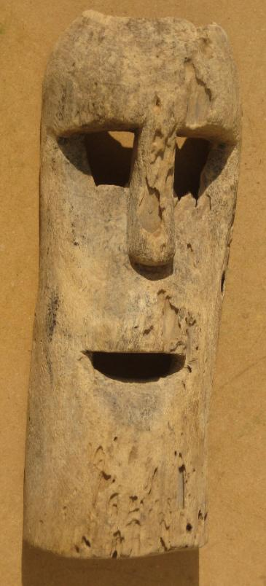 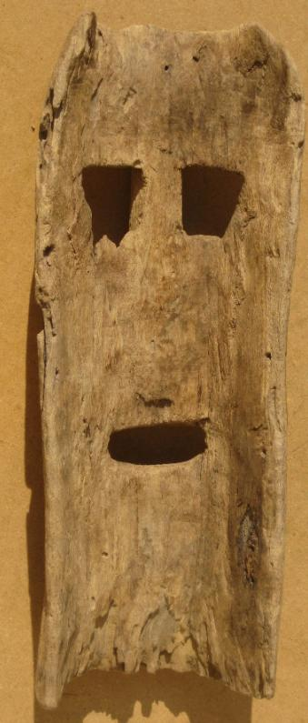

Figs. 1-2. Afr-Ghana-Tchamba-Mask-Wood-late 19th c

Case No.: 6

**Accession No.**

**Formal Label:** Afr-Ghana-Tchamba-Mask-Wood-late 19th c

**Display Description:**

An old intact wooden mask from the Tchamba people originally a tribe in present day Ghana who were known as the aborigines ( indigenous) of Northern Ghana, in Tamale, Bim Billa, Tikokonba (known as Konkonba) Nanumba and other areas. Due to major tribal wars they had to flee to present day Tchamba in Northern Togo. This mask was possibly carved before these migrations to Togo.  Two drill holes (one field repaired) on either side for raffia decoration or hold-strap.

**LC Classification:**

**Date or Time Horizon:**

**Geographical Area:**

**Map:**

Tchamba today is a city located in [Tchamba Prefecture](http://en.wikipedia.org/wiki/Tchamba_Prefecture) in the [Centrale Region](http://en.wikipedia.org/wiki/Centrale_Region) of [Togo](http://en.wikipedia.org/wiki/Togo).

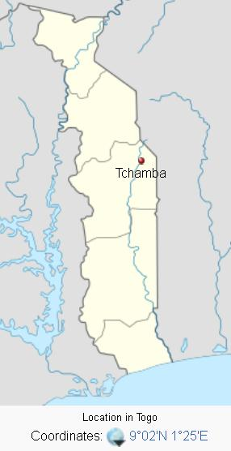

**GPS coordinates:**

**Cultural Affiliation:**

**Medium:** Light-to-medium density wood, with **Dimensions: H** 14 in; W 5.4 in

**Weight:** 1.1 lbs.

**Condition:** superficial insect damage.

**Provenance: Tamale, Ghana**

**Discussion:**

**References:**